**R54_M8_Class09_Works (Explaination)**

The code represents a database model using Entity Framework Core for a job portal application. Let's break down the model and explain the relationships between the entities:

1. **AppUser:**
   * This is the base class that inherits from IdentityUser. It's used for authentication and authorization purposes and represents a user in the application.
2. **JobProvider:**
   * Inherits from AppUser. This entity represents a job provider or a company that posts job listings.
   * Properties:
     + CompanyName: The name of the company.
     + CompanyAddress: The address of the company.
     + JobPosts: A collection of JobPost entities, representing the job listings posted by this job provider.
3. **JobSeeker:**
   * Inherits from AppUser. This entity represents a job seeker, an individual looking for job opportunities.
   * Properties:
     + FullName: The full name of the job seeker.
     + BirthDate: The birthdate of the job seeker.
     + ContactNumber: The contact number of the job seeker.
     + JobSeekerJobPosts: A collection of JobSeekerJobPost entities, representing the job posts that the job seeker has shown interest in or applied to.
4. **JobPost:**
   * Represents a job listing posted by a job provider.
   * Properties:
     + JobPostId: An identifier for the job post.
     + UserId: A foreign key to the associated JobProvider. It establishes a relationship between the job post and the job provider who posted it.
     + JobPostName: The name/title of the job post.
     + Salary: The salary for the job.
     + Position: The position or job title.
     + Location: The location of the job.
     + Description: A description of the job.
     + JobProvider: A navigation property representing the associated job provider.
     + JobSeekerJobPosts: A collection of JobSeekerJobPost entities, representing the job seekers who have shown interest in or applied to this job post.
5. **JobSeekerJobPost:**
   * Represents the relationship between job seekers and job posts, indicating which job posts a job seeker has shown interest in or applied to.
   * Properties:
     + Id: An identifier for the relationship.
     + UserId: A foreign key to the associated JobSeeker. It establishes a relationship between the job seeker and the job post.
     + JobPostId: A foreign key to the associated JobPost. It establishes a relationship between the job post and the job seeker.
     + JobSeeker: A navigation property representing the associated job seeker.
     + JobPost: A navigation property representing the associated job post.
6. **AppDbContext:**
   * This is the database context class that inherits from IdentityDbContext<AppUser>. It's responsible for defining the database schema and handling interactions with the database.
   * It includes DbSet properties for each of the entity types, allowing you to query and interact with the database using Entity Framework Core.

In summary, the model represents a job portal application with entities for job providers, job seekers, job posts, and the relationship between job seekers and job posts. The relationships are established through foreign keys, and the database context class

provides the necessary configuration for Entity Framework Core to work with these entities and manage the database.

**In the provided code, there are two types of relationships:**

1. **One-to-Many Relationship**:
   * The one-to-many relationship is represented between **JobProvider** and **JobPost**. One job provider can have multiple job posts, but each job post belongs to only one job provider.
   * This relationship is established through the navigation property **JobPosts** in the **JobProvider** class:
     + **JobProvider** (One) -> **JobPosts** (Many)
2. **Many-to-Many Relationship**:
   * The many-to-many relationship is represented between **JobSeeker** and **JobPost** through the **JobSeekerJobPost** intermediary entity. A job seeker can show interest in or apply to multiple job posts, and a job post can receive interest or applications from multiple job seekers.
   * This relationship is established through the **JobSeekerJobPost** entity, which has foreign keys to both **JobSeeker** and **JobPost**:
     + **JobSeeker** (Many) <- **JobSeekerJobPost** -> **JobPost** (Many)
   * The **JobSeekerJobPost** entity acts as a bridge table linking job seekers to job posts, creating a many-to-many relationship between them.

In summary:

* **JobProvider** and **JobPost** have a one-to-many relationship.
* **JobSeeker** and **JobPost** have a many-to-many relationship facilitated by the **JobSeekerJobPost** entity.

**IdentityDbSeeder / Hosted Services**

private readonly UserManager<AppUser> userManager;

private readonly RoleManager<IdentityRole> roleManager;

private readonly AppDbContext;

In the code snippet, there are three private fields that are injected into the constructor of the class:

1. **userManager:**
   * This is an instance of UserManager<AppUser>. UserManager is a class provided by ASP.NET Core Identity that allows you to manage user-related operations, such as creating, updating, and deleting users. In this case, it's specifically configured to work with the AppUser entity, which is used to represent users in the application.
2. **roleManager:**
   * This is an instance of RoleManager<IdentityRole>. RoleManager is another class provided by ASP.NET Core Identity, and it's used to manage roles within the application. It allows you to create, update, delete, and query roles. Here, it's configured to work with IdentityRole, which represents roles in the application.
3. **appDbContext:**
   * This is an instance of AppDbContext. AppDbContext is a custom database context class that you've defined for your application, typically extending DbContext from Entity Framework Core. It's used to interact with the database, including querying and modifying data.

These three fields are typically injected into the constructor using dependency injection, which is a common practice in ASP.NET Core applications. Dependency injection allows you to provide necessary services and dependencies to a class rather than creating them directly within the class. This promotes modularity and testability in your application, as you can easily replace these services with mocks or stubs during testing.

By injecting userManager, roleManager, and appDbContext into your class, you can use these services to perform various tasks related to user management and database operations within the class's methods. This approach adheres to the principles of separation of concerns and makes your code more maintainable and testable.

**IHostedService**

**IHostedService** is an interface in ASP.NET Core and .NET Core that is part of the Microsoft.Extensions.Hosting namespace. It is used to define background tasks or services that run within the host of your application. These services are typically used for running tasks that need to be executed asynchronously and independently of the main application logic.

Here's how **IHostedService** works:

1. **Implementing the Interface:** To use **IHostedService**, you need to create a class that implements this interface. The interface defines two methods: **StartAsync(CancellationToken)** and **StopAsync(CancellationToken)**.
   * **StartAsync(CancellationToken)**: This method is called when the application starts, and it should contain the code that starts your background task or service.
   * **StopAsync(CancellationToken)**: This method is called when the application is shutting down, and it should contain the code to gracefully stop your background task or service.
2. **Registration**: You then register your **IHostedService** implementation with the ASP.NET Core dependency injection container during application startup. This can be done in the **Startup.cs** file or elsewhere in your application's configuration.

**csharpCopy code**

**services.AddHostedService<MyBackgroundService>();**

In this example, **MyBackgroundService** is the class that implements **IHostedService**.

1. 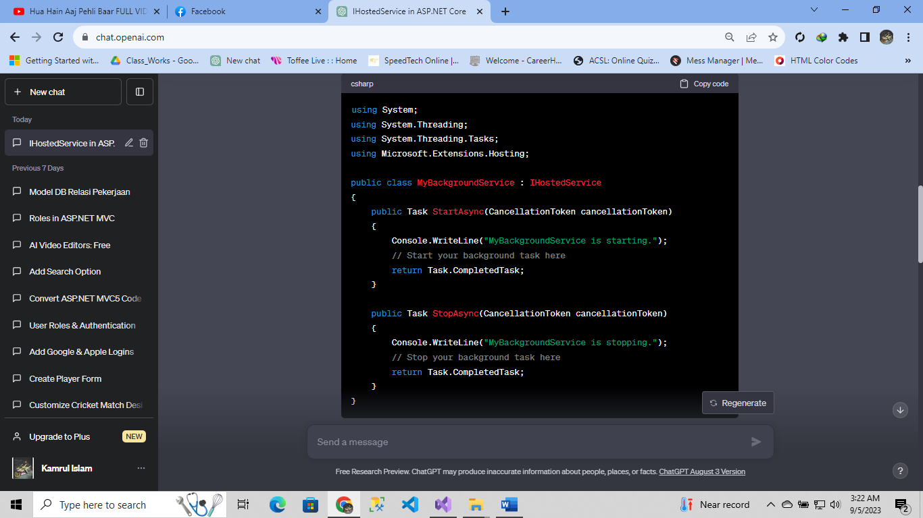**Execution**: When the application starts, the **StartAsync** method of your hosted service will be called. Your background task or service can run in the background independently of the main application. When the application is shutting down, the **StopAsync** method will be called to allow your service to clean up resources gracefully.

This hosted service can perform any background processing, periodic tasks, or long-running operations that your application may require. It is a powerful feature in ASP.NET Core for managing background tasks in a structured and controlled manner.

**IServiceProvider**

IServiceProvider is an interface in .NET that defines a mechanism for retrieving services or objects that provide functionality to an application. It is a fundamental part of the dependency injection system in .NET, which allows you to manage and access various services or components in a decoupled and maintainable way.

Key points about IServiceProvider:

1. **Service Retrieval:** The primary purpose of IServiceProvider is to allow you to retrieve services or instances of objects registered with a dependency injection container. You can request a service by specifying its type, and the IServiceProvider will resolve and return an instance of that service.
2. **Dependency Injection:** .NET Core and ASP.NET Core extensively use IServiceProvider for implementing the dependency injection pattern. Dependency injection helps manage dependencies between classes, making your code more modular, testable, and maintainable.
3. **Registration:** Before you can retrieve services from an IServiceProvider, you need to register them with a service collection or container. This registration typically occurs during application startup. For example, in ASP.NET Core, services are registered in the Startup.cs file's ConfigureServices method.

**csharpCopy code**

services.AddTransient<IMyService, MyService>();

In this example, IMyService is the service interface, and MyService is the implementation that will be resolved when requested.

1. Scoped, Transient, and Singleton Services: When registering services, you can specify their lifetimes:
   * Transient: A new instance of the service is created every time it's requested.
   * Scoped: A single instance is created per HTTP request or a similar scope.
   * Singleton: A single instance is created and shared across the entire application's lifetime.
2. **Custom Services:** You can register not only built-in .NET services but also your own custom services and objects. This allows you to manage various parts of your application, such as data repositories, logging, configuration, and more, through dependency injection.
3. **Usage:** Once services are registered, you can access them within your application components, such as controllers, services, or middleware, by requesting them through the IServiceProvider. For example:

**csharpCopy code**

public class MyController : ControllerBase

{

private readonly IMyService _myService;

public MyController(IMyService myService)

{

_myService = myService;

} // ...

}

In this example, IMyService is injected into the controller's constructor, and the IServiceProvider automatically provides the appropriate instance of MyService.

1. Service Resolution: The way services are resolved may vary depending on the specific dependency injection container you are using. In .NET Core and ASP.NET Core, the built-in container handles service resolution using IServiceProvider.
2. Testing: Using IServiceProvider and dependency injection makes it easier to write unit tests for your code by allowing you to provide mock or test implementations of services.

In summary, IServiceProvider is a fundamental component in .NET's dependency injection system, enabling you to manage and access services and objects in a flexible and modular way, which promotes better code organization and testability.

**IdentityDbSeeder**

 The **IdentityDbSeeder** class is a part of a hosted service in an ASP.NET Core application, and its purpose is to seed (create) roles using the ASP.NET Core Identity framework. Roles are used to manage and define access rights and permissions within the application.

Here's an explanation of the key components and functionality of the **IdentityDbSeeder** class:

1. **Constructor**:
   * The constructor of the **IdentityDbSeeder** class takes three parameters: **appDbContext**, **userManager**, and **roleManager**. These parameters are typically injected by the dependency injection system in ASP.NET Core.
2. **appDbContext**:
   * This is an instance of the **AppDbContext** class, which represents the database context for your application. It's used to interact with the database, including creating and managing roles.
3. **userManager**:
   * **userManager** is an instance of the **UserManager<AppUser>** class, provided by ASP.NET Core Identity. It allows you to manage user-related operations, such as creating and managing users.
4. **roleManager**:
   * **roleManager** is an instance of the **RoleManager<IdentityRole>** class, also provided by ASP.NET Core Identity. It is used for managing roles, including creating and checking the existence of roles.
5. **Constructor Logic**:
   * Within the constructor, there is a check to see if the database can be connected to (**appDbContext.Database.CanConnect()**). If the database can't be connected, it attempts to ensure that the database is created using **appDbContext.Database.EnsureCreated()**. This is typically used for database initialization, ensuring that the database schema is created if it doesn't exist.
6. **SeedAsync() Method**:
   * The **SeedAsync** method is responsible for seeding roles in the database. It creates two roles: "JobSeeker" and "JobProvider."
7. **CreateRoleAsync() Method**:
   * This private method is used to create a role if it does not already exist. It takes an **IdentityRole** object as a parameter.
   * It checks if the role already exists using **roleManager.RoleExistsAsync(role.Name ?? "")**. If the role doesn't exist (**!exists**), it creates the role using **roleManager.CreateAsync(role)**.

Overall, the **IdentityDbSeeder** class is used during application startup to ensure that the required roles ("JobSeeker" and "JobProvider") exist in the application's database. This is a common practice in role-based authorization systems to set up the initial roles and permissions for users in the application.

**AccountController**

The code you provided is a part of an ASP.NET Core MVC application and represents the **AccountController**. This controller is responsible for handling user-related actions, such as registration, login, and logout. It also includes dependency injection of **SignInManager**, **RoleManager**, and **UserManager**, which are key components of ASP.NET Core Identity for managing user authentication, authorization, and roles.

Here's a breakdown of the key components and actions in the **AccountController**:

1. **Constructor**:
   * The constructor of the **AccountController** class injects three important services:
     + **SignInManager<AppUser>** (**signInManager**): Used for handling user sign-in and sign-out functionality.
     + **RoleManager<IdentityRole>** (**roleManager**): Used for managing user roles within the application.
     + **UserManager<AppUser>** (**userManager**): Used for managing user-related operations, such as user creation and querying.
2. **Register() Action**:
   * The **Register** action is responsible for rendering the registration form. It returns a view that displays the registration form to the user.
3. **[HttpPost] Register() Action**:
   * This is the HTTP POST version of the registration action.
   * It receives data submitted by the user through the registration form as a **RegisterInputModel** object (**model**).
   * It checks if the model is valid (i.e., it passes validation checks).
   * If the model is valid, it creates a new **AppUser** instance with the provided username and attempts to create the user using **userManager.CreateAsync()**.
   * If the user creation is successful (**result.Succeeded** is **true**), it redirects the user to the "Login" action.
   * If the user creation fails, it adds an error message to the model state and returns the registration view again, displaying the error message to the user.
4. **Login() Action**:
   * The **Login** action renders the login form, allowing users to enter their credentials for authentication.
5. **Logout() Action**:
   * The **Logout** action is decorated with the **[Authorize]** attribute, which means it requires the user to be authenticated to access this action.
   * When accessed, it can be used to log the user out of the application. However, in your code, it simply returns a view, so it might need to include logic for actually logging the user out.

This controller provides basic functionality for user registration, login, and logout in your application. Users can access the registration and login forms, and upon successful registration, they are redirected to the login page to log in with their newly created account. It's important to note that additional implementation for user authentication and logout logic may be needed depending on your application's requirements.